

CSE 423

Lab Assignment 1

Name: S.M. ABRAR MUSTAKIM TAKI

ID: 20301125

SEC: 05

Task 1
import random

from OpenGL.GL import *
from OpenGL.GLUT import *
from OpenGL.GLU import *

#def draw_points(x, y):

def draw_points(a, b):
glPointSize(6) #pixel size. by default 1 thake
glBegin(GL_POINTS)
glVertex2f(a, b)
glEnd()

def iterate():
glViewport(0, 0, 500, 500)
glMatrixMode(GL_PROJECTION)
glLoadIdentity()
glOrtho(0.0, 500, 0.0, 500, 0.0, 1.0)
glMatrixMode (GL_MODELVIEW)
glLoadIdentity()

def showScreen():
glClear(GL_COLOR_BUFFER_BIT | GL_DEPTH_BUFFER_BIT)
glLoadIdentity()
iterate()
glColor3f(1.0, 0.0, 0.0) #konokichur color set (RGB)
#call the draw methods here
#draw_points()
for i in range(50):
a = random.randint(1, 490)
b = random.randint(1, 490)
glColor3f(0.01*i, 0.02*i, 0.3*i)
draw_points(a, b)
glutSwapBuffers()

glutInit()
glutInitDisplayMode(GLUT_RGBA)
glutInitWindowSize(500, 500) #window size
glutInitWindowPosition(0, 0)
wind = glutCreateWindow(b"Drawing Pixels") #window name
glutDisplayFunc(showScreen)

glutMainLoop()

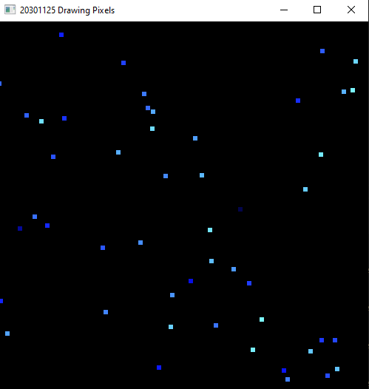

Task 2
import random

from OpenGL.GL import *
from OpenGL.GLUT import *
from OpenGL.GLU import *

def draw_quads(a, b): #200,0
glPointSize(1) #pixel size. by default 1 thake
glBegin(GL_LINES)
glVertex2f(a, b) # starting point of trunk #200,0
glVertex2f(a+200, b) #400, 0
glVertex2f(a+200, b) #400, 0
glVertex2f(a+200, a) #400, 200
glVertex2f(a+200, a) #400, 200
glVertex2f(a, a) #200, 200
glVertex2f(a, a) #200, 200
glVertex2f(a, b) #400, 0
#glVertex2f(a+200, a) #400, 200
#glVertex2f(a+200, b) #400, 0
glEnd()

def window(a, b): #210, 100
glPointSize(1) #pixel size. by default 1 thake
glBegin(GL_LINES)
glVertex2f(a, b) # starting point of trunk #210, 100
glVertex2f(a+50, b) #260, 100
glVertex2f(a+50, b) #260, 100
glVertex2f(a+50, b+50) #260, 150
glVertex2f(a+50, b+50) #260, 150
glVertex2f(a, b+50) #210, 150
glVertex2f(a, b+50) #210, 150
glVertex2f(a, b)
glEnd()

def door(a, b): #270, 0
glPointSize(1) #pixel size. by default 1 thake
glBegin(GL_LINES)
glVertex2f(a, b) # starting point of trunk #270, 0
glVertex2f(a+50, b) #320, 0
glVertex2f(a+50, b) #320, 0
glVertex2f(a+50, b+100) #320, 100
glVertex2f(a+50, b+100) #320, 100
glVertex2f(a, b+100) #270, 100
glVertex2f(a, b+100) #270, 100
glVertex2f(a, b)
glEnd()
'''
def draw_triangle():
glPointSize(10) #pixel size. by default 1 thake
glBegin(GL_LINES)
glVertex2f(200, 200) # starting point of trunk
glVertex2f(300, 350)
glVertex2f(300, 350)
glVertex2f(400, 200)
glEnd()
'''
def draw_triangle():
glPointSize(10) #pixel size. by default 1 thake
glBegin(GL_TRIANGLES)
glVertex2f(200, 200) # starting point of trunk
glVertex2f(400, 200)
glVertex2f(300, 350)

glEnd()

def draw_points(a, b):
glPointSize(5) #pixel size. by default 1 thake
glBegin(GL_POINTS)
glVertex2f(a, b)
glEnd()

def iterate():
glViewport(0, 0, 500, 500)
glMatrixMode(GL_PROJECTION)
glLoadIdentity()
glOrtho(0.0, 500, 0.0, 500, 0.0, 1.0)
glMatrixMode (GL_MODELVIEW)
glLoadIdentity()

def showScreen():
glClear(GL_COLOR_BUFFER_BIT | GL_DEPTH_BUFFER_BIT)
glLoadIdentity()
iterate()
glColor3f(1.0, 1.0, 0.0) #konokichur color set (RGB)
#call the draw methods here
#draw_points()
#for i in range(50):
# a = random.randint(0, 500)
# b = random.randint(0, 500)
# draw_points(a, b)
draw_quads(200, 0)

glColor3f(1.0, 0.0, 0.0) # konokichur color set (RGB)
window(210, 100)
glColor3f(1.0, 0.0, 0.0)
window(340, 100)
glColor4f(1.0, 1, 0.0, 0.0)
draw_triangle()
glColor3f(0.0, 1.0, 0.0)
door(270, 0)
glColor3f(1.0, 0.0, 1.0)
draw_points(310, 50)
# call the draw methods here
# draw_points()
# for i in range(50):
# a = random.randint(0, 500)
# b = random.randint(0, 500)
# draw_points(a, b)
#draw_quads(150, 250)
#draw_triangle()
#draw_points(300, 300)
glutSwapBuffers()

glutInit()
glutInitDisplayMode(GLUT_RGBA)
glutInitWindowSize(500, 500) #window size
glutInitWindowPosition(0, 0)
wind = glutCreateWindow(b"20301125 House Building") #window name
glutDisplayFunc(showScreen)

glutMainLoop()
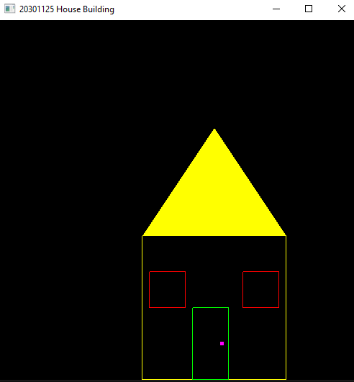

TASK 3
import random
from OpenGL.GL import *
from OpenGL.GLUT import *
from OpenGL.GLU import *
def draw_line():
glPointSize(10) #pixel size. by default 1 thake
glBegin(GL_LINES)
glVertex2f(250, 150) # starting point of trunk
glVertex2f(150, 250)
glVertex2f(250, 150) # starting point of trunk
glVertex2f(350, 150)
glVertex2f(150, 250) # starting point of trunk
glVertex2f(250, 350)
glVertex2f(250, 350) # starting point of trunk
glVertex2f(350, 350)
glVertex2f(350, 350)
glVertex2f(450, 250)
glVertex2f(450, 250)
glVertex2f(350, 150)
glEnd()
def draw_two(x=100, a=100, b=200, c=70, d=50):
glPointSize(10)
glBegin(GL_LINES)
glVertex2f(x, a)
glVertex2f(b, a)
glVertex2f(b, a)
glVertex2f(b, c)
glVertex2f(b, c)
glVertex2f(x, c)
glVertex2f(x, c)
glVertex2f(x, d)
glVertex2f(b, d)
glVertex2f(x, d)
glEnd()

def draw_zero(a=210, b=250, c=100, d=50):
glPointSize(10)
glBegin(GL_LINES)
glVertex2f(a, c)
glVertex2f(b, c)
glVertex2f(b, c)
glVertex2f(b, d)
glVertex2f(b, d)
glVertex2f(a, d)
glVertex2f(a, d)
glVertex2f(a, c)
glEnd()

def draw_three(a=260, b=290, c=100, d=50):
glPointSize(10)
glBegin(GL_LINES)
glVertex2f(a, c)
glVertex2f(b, c)
glVertex2f(b, c)
glVertex2f(b, d)
glVertex2f(a, c-30)
glVertex2f(b, c-30)
glVertex2f(b, d)
glVertex2f(a, d)

glEnd()

def draw_one(a=350, c=100, d=50):
glPointSize(10)
glBegin(GL_LINES)
glVertex2f(a, c)
glVertex2f(a, d)
glEnd()

def draw_five(x=100, a=100, b=200, c=70, d=50):
glPointSize(10)
glBegin(GL_LINES)
glVertex2f(x, a)
glVertex2f(b, a)
glVertex2f(x, a)
glVertex2f(x, c)
glVertex2f(b, c)
glVertex2f(x, c)
glVertex2f(b, c)
glVertex2f(b, d)
glVertex2f(b, d)
glVertex2f(x, d)
glEnd()

def iterate():
glViewport(0, 0, 500, 500)
glMatrixMode(GL_PROJECTION)
glLoadIdentity()
glOrtho(0.0, 500, 0.0, 500, 0.0, 1.0)
glMatrixMode (GL_MODELVIEW)
glLoadIdentity()

def showScreen():
glClear(GL_COLOR_BUFFER_BIT | GL_DEPTH_BUFFER_BIT)
glLoadIdentity()
iterate()
glColor3f(1.0, 0.0, 0.0) #konokichur color set (RGB)
draw_two()
glColor3f(0.0, 1.0, 0.0)
draw_zero()
glColor4f(1.0, 0.5, 0.0, 0.0)
draw_three()
glColor3f(0.0, 0.0, 1.0)
draw_zero(300, 340)
glColor3f(0.5, 0.5, 0.5)
draw_one()
glColor3f(2.0, 0.5, 1.0) #lillac
draw_one(a=360)
glColor3f(0.5, 1.0, 1.0)
draw_two(x=370, b=400)
glColor4f(1.0, 1.0, 1.0, 0.0) #CMYK
draw_five(x=410, b=450)
glutSwapBuffers()

glutInit()
glutInitDisplayMode(GLUT_RGBA)
glutInitWindowSize(500, 500) #window size
glutInitWindowPosition(0, 0)
wind = glutCreateWindow(b"Student ID") #window name
glutDisplayFunc(showScreen)

glutMainLoop()
